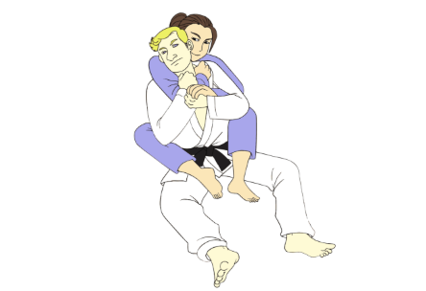

I built an interactive BJJ Positional Hierarchy chart with video tutorials for each technique

Hey everyone! I built a free interactive positional hierarchy chart that maps out positions from best to worst with clickable techniques. Each technique opens an embedded YouTube tutorial video right on the page
Covers: Back control, Mount, Side control, Guard (top & bottom), Half guard, and the worst positions with escapes.
Mostly aimed at white/blue belts who want a visual roadmap of where they are and what options they have from each position.
Check it out: https://jiu-jitsu-positions.vercel.app/
Would love any feedback — especially if you think I'm missing key techniques or have better video recommendations for any of the positions. OSS!

